Assessment Schedule – 2013

Physics: Demonstrate understanding of wave systems (91523)

Assessment Criteria
Achievement | Achievement with Merit | Achievement with Excellence
Demonstrate understanding requires writing statements that typically show an awareness of how simple facets of phenomena, concepts or principles relate to a described situation. For mathematical solutions, relevant concepts will be transparent, methods will be straightforward. | Demonstrate in-depth understanding requires writing statements that will typically give reasons why phenomena, concepts or principles relate to given situations. For mathematical solutions the information may not be directly usable or immediately obvious. | Demonstrate comprehensive understanding requires writing statements that will typically give reasons why phenomena, concepts or principles relate to given situations. Statements will demonstrate understanding of connections between concepts.

Evidence Statement
NØ = No response; no relevant evidence.

One | Evidence |  | Achievement |  | Achievement with Merit |  | Achievement with Excellence
(a) | N  A |  | - Correct shape and labels drawn
(b) | - λ=v / f  343 / 1904=0.18 m.  0.18 / 4=0.045m  0.045m = 45mm |  | - Correct wavelength.  - Divides calculated wavelength by four. |  | - 0.045m / 45mm
(c) | Sound waves enter at the open end, travel along the pipe and reflect from the closed end. Reflected waves are out of phase making the closed end a place of permanent destructive interference (a node). Reflected waves of the correct wavelength reflect from the open end in phase with incident waves, producing a position of permanent constructive interference (an antinode) . Amplitude at antinode is larger than amplitude of the wave |  | - Node is destructive interference (zero amplitude)/ antinode is constructive interference (maximum amplitude).  - System is forced to vibrate at its natural frequency (driving frequency = natural frequency).  - λ/4 (or 3λ/4) fits in the pipe  - wave changes phase/inverts after reflection at the closed end.  - (BOTH of Closed end is a node: Open end is an antinode replacement evidence for 1a only). |  | - Position of node and antinode linked to type of interference occurring.  - Position of node and antinode linked to phase of the wave after reflection |  | - Complete correct answer linking position of antinode and node to phase change upon reflection of waves with the correct wavelength / frequency./ λ/4 fits in the pipe
(d) | Overtones in shorter chamber produced at 6408Hz, 10680Hz. Overtones in longer chamber produced at 5712Hz, 9520Hz. Mixture of overtones produces distinctive sound (timbre) of the whistle. Difference tones/beats can be produced between fundamental frequencies |  | - Two frequencies correctly calculated.  - Timbre is the distinctive sound.  - Describes beats at 232Hz |  | - Shows understanding that only odd harmonics of the frequencies of each chamber are produced. E.g. deliberately leaving out even multiples  - Fundamental /overtone frequencies interfere/combine to produce a different sound. |  | - Complete answer linking the timbre/quality/unique sound produced to combination/interference of correct odd multiples of the fundamental frequencies of each of the two chambers.
Q1 | Not Achieved |  | Achievement |  | Achievement with Merit |  | Achievement with Excellence
Q1 | N1 | N2 | A3 | A4 | M5 | M6 | E7 | E8
Q1 | ONE point | TWO point | THREE points | FOUR points | TWO points | THREE points | ONE point | TWO points

Two |  | Evidence |  |  | Achievement |  |  | Achievement with Merit |  |  | Achievement with Excellence
(a) | Velocity unchanged and wavelength shortened |  |  | - Velocity unchanged  - Wavelength shortened
(b) | Relative velocity between ambulance and policeman remains unchanged.  Relative velocity determines the Doppler shifted frequency |  |  | - Wavelength/relative velocity not changing  - Doppler shift doesn’t depend on distance from source |  |  | - Complete correct answer linking unchanging relative velocity to unchanging doppler shifted frequency
(c) | 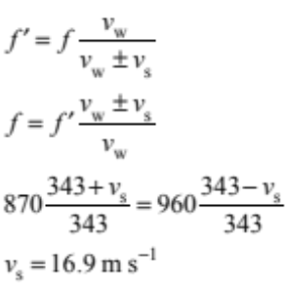 |  |  | - 870 = 960(343 / (343 + v_{s}))  v_{s} = 35.5 m s^{–1}  - 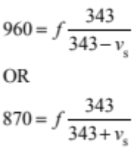 |  |  | - Correct substitutions into rearranged formula:  - 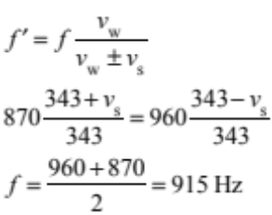  leading to speed of 16.1 or 17.7 m/s |  |  | - Correct speed found: 16.9 m s^{–1}
(d) | Apparent frequency would drop as the ambulance accelerated because the distance traveled by the ambulance between the creation of each wave is increasing (relative velocity of the ambulance to the policeman is increasing / actual wavelength is increasing) but the velocity of sound in air remains constant. The ambulance’s velocity determines the amount of doppler shift he perceives, and as this is dropping, the frequency will rise towards the actual frequency. |  |  | - Frequency drops as the ambulance accelerates away OR Frequency rises as the ambulance slows and stops |  |  | - Apparent frequency would drop as the ambulance accelerated away because relative velocity / wavelength is increasing.  OR  - Frequency would rise as the ambulance slowed to a stop because relative velocity / wavelengthy is decreasing. |  |  | - Drop in observed frequency as the ambulance accelerates away linked to increasing distance between waves / increasing wavelength.  AND  - As the ambulance slows / stops the (wavelength quickly reduces to normal length and) the observed frequency rises back up to the actual frequency (913Hz).
Q2 |  | Not Achieved |  |  | Achievement |  |  | Achievement with Merit |  |  | Achievement with Excellence
 |  | N1 | N2 |  | A3 | A4 |  | M5 | M6 |  | E7 | E8
 |  | ONE point | TWO point |  | THREE points | FOUR points |  | TWO points | THREE points |  | ONE point | BOTH points

Three | Evidence |  | Achievement |  | Achievement with Merit |  | Achievement with Excellence
(a) | Images of the lights appear on either side |  | - Images of the lights appear on either side / bright and dark / interference pattern.
(b) | 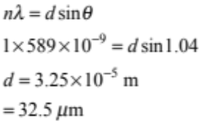 |  | - Correct substitution. |  | - Correct working and answer.
(c) | Constructive interference occurs much less frequently because of the many sources so the bright fringes are much narrower / more defined  The bright fringes are brighter because they are formed from constructive interference of light from many extra sources |  | - Bright fringes are narrower / more defined OR dark fringes are wider.  - Fringes are brighter. |  | - Constructive interference occurs much less frequently because of the many sources so the bright fringes are much narrower / more defined.  - The bright fringes are brighter because they are formed from constructive interference of light from many extra sources. |  | - Both the narrowness and the brightness of the fringes are correctly explained.
(d) | The white light contains all the colours of visible light. All frequencies diffract as they pass through the diffraction grating and spread out through 180°. The frequencies with the shortest wavelengths are violet and the longest wavelengths are red. The longer the wavelength, the larger the angle will be to the first order maximum, so the further the colour will be seen from the centre |  | - The diffraction grating causes separation of the white light into a spectrum of colours.  - White in the middle.  - Violet closest to centre / red furthest out. |  | - Correctly linking the position of colours in spectrum to frequency or wavelength. |  | - Increasing wavelength linked to increase in angle at which the first order maximum occurs to explain the order of the colours from violet through to red.
Q3 | Not Achieved |  | Achievement |  | Achievement with Merit |  | Achievement with Excellence
Q3 | N1 | N2 | A3 | A4 | M5 | M6 | E7 | E8
Q3 | ONE point | TWO point | THREE points | FOUR points | TWO points | THREE points | ONE point | BOTH points

Judgement Statement
 | Not Achieved | Achievement | Achievement with Merit | Achievement with Excellence
Score range | 0 – 6 | 7 – 12 | 13 – 18 | 19 – 24

